JOMO KENYATTA UNIVERSITY OF AGRICULTURE AND TECHNOLOGY

DEPARTMENT OF INFORMATION TECHNOLOGY

NEXTGEN BANK: AI-POWERED ONLINE BANKING SYSTEM WITH INTELLIGENT CUSTOMER SUPPORT, ENHANCED SECURITY FEATURES, AND CRYPTOCURRENCY INTEGRATION

BY

KIRIKA MARTIN NJUGUNA
HDB212-0348/2022

Supervisor: RON MUHANDE

A Project Report Submitted to the Department of Information Technology
in the School of Computing and Information Technology
in Partial Fulfilment of the Requirements for the Award of the Degree of
Bachelor of Science in Computer Science
of Jomo Kenyatta University of Agriculture and Technology

June, 2026

DECLARATION AND APPROVAL

DECLARATION
I hereby declare that this Project Report is my own work and has, to the best of my knowledge, not been submitted to any other institution of higher learning for any award.

Student Name: KIRIKA MARTIN NJUGUNA
Registration Number: HDB212-0348/2022
Signature: ........................................................... Date: .............................................

APPROVAL
This project report has been submitted with my approval as the University supervisor.

Supervisor Name: RON MUHANDE
Signature: ........................................................... Date: .............................................

DEDICATION
This project is dedicated to my family, whose unwavering support, patience and encouragement sustained me through every challenge encountered in the course of this work. Your belief in my potential provided the strength I needed to see this project through to completion.
To my supervisor, Mr. Ron Muhande, whose guidance, critical feedback and direction kept this project grounded and purposeful, I express my deepest gratitude.
To every student at JKUAT and beyond who aspires to use technology to solve real problems in the financial sector, may this work serve as evidence that innovation is within reach.

ACKNOWLEDGEMENTS
I wish to express my sincere gratitude to all those who contributed to the successful completion of this project.
I am deeply grateful to my supervisor, Mr. Ron Muhande, for his consistent guidance, constructive criticism and availability throughout the design, development and documentation phases of this project. His counsel sharpened the quality of both the system and the academic contribution.
I extend my appreciation to the staff and administration of the Department of Information Technology at Jomo Kenyatta University of Agriculture and Technology for providing the academic foundation on which this work was built.
I acknowledge the developers and documentation teams behind the NOWPayments API, Safaricom Daraja, and the open-source technologies employed in this project. Their publicly available resources made advanced integrations achievable within the constraints of an academic project.
Finally, I thank my classmates and colleagues in the School of Computing and Information Technology for their collaboration, technical discussions and camaraderie throughout the programme.

ABSTRACT
This project report presents NextGen Bank, a fully implemented AI-powered online banking system developed to address critical challenges in Kenya's digital banking landscape, including lack of transparency in fee structures, inadequate customer support, authentication difficulties, and limited access to alternative deposit mechanisms. The system was built using a React Native mobile frontend, a Node.js and Express backend, and a JSON-based data store, deployed and tested across Android and iOS devices. Four core modules were delivered: a user authentication module with Two-Factor Authentication (2FA) using authenticator app-based time-based one-time passwords (TOTP); an account management module supporting Savings, Checking and Crypto Wallet account types; an M-Pesa deposit and withdrawal module integrated with the Safaricom Daraja STK Push API; and a cryptocurrency deposit module integrated with the NOWPayments payment gateway using Instant Payment Notifications (IPN) for automated deposit confirmation. The admin portal, built as a web application, provides oversight of users, accounts, transactions, and cryptocurrency deposit management with real-time status tracking. Security was implemented through bcrypt password hashing, JWT session management, TOTP-based 2FA, and role-based access control. Cryptocurrency integration using NOWPayments supports USDT (TRC20) on the Tron Network and Litecoin (LTC), with automatic IPN callbacks updating deposit status upon blockchain confirmation. The system was tested across twenty test cases covering functional, security, integration and compatibility categories, all of which passed. The project demonstrates that advanced financial technology features, including cryptocurrency deposits, two-factor authentication and M-Pesa integration, can be meaningfully combined in a single mobile banking platform tailored to the Kenyan market.

TABLE OF CONTENTS
DECLARATION AND APPROVAL 2
DECLARATION 2
APPROVAL 2
DEDICATION 3
ACKNOWLEDGEMENTS 4
ABSTRACT 5
TABLE OF CONTENTS 6
LIST OF FIGURES 9
LIST OF ABBREVIATIONS 10
CHAPTER ONE: INTRODUCTION 11
1.1 Background of the Study 11
1.2 Project Overview 11
1.3 Problem Statement 12
1.4 Proposed Solution 12
1.5 Objectives of the Study 13
1.5.1 General Objective 13
1.5.2 Specific Objectives 13
1.6 Research Questions 13
1.7 Justification of the Study 14
1.8 Proposed System Methodology 14
1.9 Scope of the Study 15
1.10 Significance of the Study 15
CHAPTER TWO: LITERATURE REVIEW 16
2.1 Introduction 16
2.2 Theoretical Review 16
2.2.1 Digital Banking and Mobile-First Design 16
2.2.2 Security in Digital Banking 16
2.2.3 Cryptocurrency in Banking and Finance 17
2.3 Related Systems 18
2.3.1 M-Pesa Mobile Money Platform 18
2.3.2 Revolut Digital Banking Platform 18
2.3.3 Equity Bank Equitel Mobile Banking 18
2.4 Limitations of Existing Systems 19
2.5 Summary of Literature Review 19
CHAPTER THREE: METHODOLOGY 20
3.1 Introduction 20
3.2 System Development Methodology 20
3.3 Feasibility Study 20
3.3.1 Economic Feasibility 20
3.3.2 Technical Feasibility 20
3.3.3 Operational Feasibility 21
3.3.4 Schedule Feasibility 21
3.4 Requirements Elicitation 21
3.4.1 Data Collection Methods 21
3.4.2 Key Findings from Elicitation 21
3.5 System Requirements Specification 22
3.5.1 Functional Requirements 22
3.5.2 Non-Functional Requirements 23
3.6 Requirements Analysis and Modelling 23
3.7 Logical Design 24
3.7.1 System Architecture 24
3.7.2 Workflow Design 24
CHAPTER FOUR: SYSTEM ANALYSIS, DESIGN AND IMPLEMENTATION 26
4.1 Introduction 26
4.2 System Analysis 26
4.2.1 Analysis of the Existing System 26
4.2.2 Weaknesses Identified 26
4.2.3 System Architecture 26
4.3 System Requirements 27
4.4 System Design 27
4.4.1 Architectural Design 27
4.4.2 Database Design 27
4.4.3 User Interface Design 28
4.4.4 Sign In Screen 28
4.4.5 Create Account Screen 28
4.4.6 Two-Factor Authentication Screen 29
4.4.7 Dashboard (Home Screen) 29
4.4.8 All Accounts View 30
4.4.9 Transfer Money Screen 30
4.4.10 M-Pesa Integration 30
4.4.11 Cryptocurrency Deposit Integration 31
4.4.12 IPN (Instant Payment Notification) Processing 31
4.4.13 Crypto Deposit History 32
4.4.14 User Profile Screen 32
4.4.15 Administrative Portal 33
4.5 Implementation 34
4.5.1 Technology Stack 35
4.5.2 Key Implementation Excerpts 35
4.6 System Testing 36
4.6.1 Test Plan 36
4.6.2 Test Cases 36
4.6.3 Testing Strategies Applied 38
CHAPTER FIVE: CONCLUSIONS AND RECOMMENDATIONS 39
5.1 Introduction 39
5.2 Achievements 39
5.3 Lessons Learned 39
5.4 Conclusions 40
5.5 Recommendations 41
REFERENCES 43
APPENDIX A: PROJECT SCHEDULE 45
APPENDIX B: PROJECT BUDGET 45

LIST OF FIGURES
Figure 4.1: NextGen Bank System Architecture Diagram
Figure 4.2: Mobile Application – Sign In Screen
Figure 4.3: Mobile Application – Create Account Screen
Figure 4.4: Mobile Application – Two-Factor Authentication Screen
Figure 4.5: Mobile Application – Dashboard (Home Screen)
Figure 4.6: Mobile Application – All Accounts View
Figure 4.7: Mobile Application – Transfer Money Screen
Figure 4.8: Mobile Application – M-Pesa Deposit Screen
Figure 4.9: Mobile Application – Crypto Deposit Screen (Currency Selection)
Figure 4.10: Mobile Application – Crypto Deposit QR Code and Wallet Address
Figure 4.11: Mobile Application – Crypto Deposit History
Figure 4.12: Mobile Application – User Profile Screen
Figure 4.13: Mobile Application – Profile Security and Accounts Section
Figure 4.14: Admin Portal – Dashboard Overview
Figure 4.15: Admin Portal – User Management
Figure 4.16: Admin Portal – Account Management
Figure 4.17: Admin Portal – Transaction History
Figure 4.18: Admin Portal – Crypto Deposit Management

LIST OF ABBREVIATIONS
2FA Two-Factor Authentication
AI Artificial Intelligence
API Application Programming Interface
CBK Central Bank of Kenya
CSRF Cross-Site Request Forgery
IPN Instant Payment Notification
JWT JSON Web Token
KES Kenya Shilling
LTC Litecoin
MFA Multi-Factor Authentication
NLP Natural Language Processing
OTP One-Time Password
PWA Progressive Web Application
TOTP Time-Based One-Time Password
TRC20 Token standard on the Tron blockchain network
USD United States Dollar
USDT Tether (USD-pegged stablecoin)

CHAPTER ONE: INTRODUCTION

1.1 Background of the Study
The global banking industry has undergone profound digital transformation over the past decade, driven by technological innovation, shifting consumer expectations and competitive pressure from fintech entrants. According to McKinsey & Company (2024), over 75% of banking customers worldwide now prefer digital channels for routine transactions. Artificial intelligence has emerged as a transformative force, with leading institutions deploying AI-powered chatbots, fraud detection engines and personalised advisory systems that simultaneously reduce operational cost and improve customer satisfaction.
Kenya occupies a unique position in this global landscape. The success of M-Pesa has made the country a global reference point for mobile money innovation, with the platform serving more than 30 million users and processing transactions equivalent to over 50% of national GDP annually. However, traditional online banking has not kept pace. The Central Bank of Kenya (2024) reported that while mobile money penetration exceeded 80% among adults, only 26% actively used online banking platforms. Customer complaints regarding digital banking grew by 35% year-on-year, driven primarily by hidden fees, poor user experience, inadequate support and security concerns.
Within this context of growing demand and unmet expectations, the cryptocurrency sector has added a new dimension to digital finance. Global adoption of cryptocurrencies as a store of value and payment mechanism has accelerated, with over 420 million crypto users worldwide as of 2023 (Crypto.com, 2023). Kenyan investors and diaspora communities in particular have shown strong interest in cryptocurrency as an alternative savings and remittance tool, creating demand for banking platforms that bridge traditional banking with crypto assets. The integration of regulated cryptocurrency deposit mechanisms into a banking application directly addresses this emerging customer need.
NextGen Bank was conceived to address these converging demands: the need for a secure, transparent and AI-assisted mobile banking experience for Kenyan users, combined with a modern cryptocurrency deposit channel that serves a growing segment of digitally sophisticated customers.

1.2 Project Overview
NextGen Bank is a mobile-first online banking application developed for Android and iOS platforms using React Native. The system provides users with multi-account management (Savings, Checking and Crypto Wallet accounts), M-Pesa integration for deposits and withdrawals via STK Push, cryptocurrency deposits through the NOWPayments gateway using USDT (TRC20) and Litecoin (LTC), and a Two-Factor Authentication security layer. An administrative portal built as a web application enables bank staff to manage users, accounts, transactions and cryptocurrency deposit approvals.
The system was developed over a period of approximately six months following an Agile Scrum methodology, with iterative sprints covering requirements analysis, design, implementation, testing and documentation.

1.3 Problem Statement
Online banking systems in Kenya face a set of persistent challenges that undermine their effectiveness. Hidden fees and opaque charge structures erode user trust, with 67% of online banking users reporting unexpected charges (Kenya Bankers Association, 2023). Authentication barriers, including account lockouts and branch-dependent password resets, account for 41% of all online banking complaints reported to the CBK (2023). Customer support mechanisms remain inadequate, with 73% of users expressing frustration with automated support systems (Strathmore University, 2023).
Beyond these established challenges, existing Kenyan banking platforms have no provision for cryptocurrency-based deposits, leaving a growing segment of crypto-holding customers without a regulated channel to convert digital assets into banking balances. The absence of two-factor authentication in many platforms also leaves accounts vulnerable to credential theft and account takeover attacks, which contributed to over KES 800 million in fraud losses documented by the Communications Authority of Kenya in 2024.

1.4 Proposed Solution
NextGen Bank addresses these problems through four integrated capabilities. First, it implements a transparent account management system with clearly displayed account balances, transaction histories and M-Pesa integration for instant deposits and withdrawals at stated rates. Second, it deploys a comprehensive Two-Factor Authentication system using time-based one-time passwords (TOTP) generated by standard authenticator applications, protecting user accounts without requiring branch visits. Third, it integrates NOWPayments as a cryptocurrency payment gateway supporting USDT (TRC20) and Litecoin (LTC), with Instant Payment Notification (IPN) callbacks enabling automated deposit confirmation upon blockchain verification. Fourth, it provides a full administrative portal enabling bank staff to monitor all system activity, manage users and accounts, and approve or investigate cryptocurrency deposits.

1.5 Objectives of the Study

1.5.1 General Objective
To design, develop and evaluate NextGen Bank, a mobile-first online banking application providing transparent account management, M-Pesa integration, Two-Factor Authentication and cryptocurrency deposit functionality for Kenyan banking customers.

1.5.2 Specific Objectives
The specific objectives of the study were as follows:
- To design and implement a secure user authentication system incorporating Two-Factor Authentication (2FA) using TOTP to protect user accounts against unauthorised access.
- To develop multi-account management functionality supporting Savings, Checking and Crypto Wallet account types with real-time balance display and transaction history.
- To implement M-Pesa integration using the Safaricom Daraja STK Push API for seamless mobile money deposits and withdrawals.
- To integrate the NOWPayments cryptocurrency payment gateway to enable deposits via USDT (TRC20) and Litecoin (LTC), with IPN-based automated confirmation upon blockchain verification.
- To build a web-based administrative portal providing bank staff with oversight of users, accounts, transactions and cryptocurrency deposit management.
- To evaluate the implemented system against defined functional, security and integration requirements through structured test cases.

1.6 Research Questions
The following research questions guided the study:
- How can Two-Factor Authentication be effectively implemented in a mobile banking application to enhance security without imposing unacceptable friction on legitimate users?
- How can the NOWPayments IPN mechanism be integrated into a Node.js backend to enable automated cryptocurrency deposit confirmation?
- To what extent do cryptocurrency and enhanced security integrations contribute to the relevance and competitiveness of a mobile banking platform in the Kenyan market?
- What system architecture and technology stack is appropriate for a scalable, secure mobile banking application targeting Kenyan users?

1.7 Justification of the Study
The Central Bank of Kenya's 2023 fintech report identified security enhancement and alternative payment channel integration as two of the most critical areas requiring investment in Kenya's digital banking sector. NextGen Bank directly responds to both imperatives. The 2FA implementation demonstrates a practical, cost-effective approach to protecting mobile banking users from credential theft and account takeover, which remains the leading cause of digital banking fraud in Kenya.
The cryptocurrency integration responds to documented demand from Kenyan investors and diaspora communities who hold digital assets but lack a regulated, bank-integrated channel for depositing them. By implementing NOWPayments with IPN callbacks, the system demonstrates how a banking application can support automated, trustworthy crypto-to-fiat deposit workflows without requiring manual administrative intervention for every transaction.
Both integrations also carry significance for the broader Kenyan fintech community. The 2FA architecture documented in this report provides a replicable pattern for other developers building security-sensitive mobile applications. The NOWPayments IPN integration provides a reference implementation for cryptocurrency gateway integration in a Node.js environment, addressing a gap in locally documented fintech solutions.

1.8 Proposed System Methodology
The project adopted an Agile Scrum methodology with two-week sprint cycles. Requirements were elicited through a combination of analysis of existing digital banking platforms, review of Central Bank of Kenya regulatory guidance and technical consultation of API documentation from Safaricom Daraja and NOWPayments. System design proceeded through architecture definition, database schema design and user interface wireframing. Implementation was conducted in iterative sprints covering authentication, account management, M-Pesa integration, cryptocurrency integration and the administrative portal. Testing was conducted continuously throughout development, with a formal test execution phase in the final sprint.

1.9 Scope of the Study
The scope of the project encompasses the mobile application, backend API and administrative web portal as described above. The mobile application was developed for Android and iOS using React Native. The backend was implemented in Node.js with Express, with JSON-based data persistence. The administrative portal was built as a standalone HTML, CSS and JavaScript web application.
The scope explicitly excludes loan processing, credit scoring, investment products, international card payment processing, physical card issuance and ATM integration. The M-Pesa integration was tested in sandbox mode. Cryptocurrency integrations were tested with real NOWPayments API calls in a controlled environment. AI chatbot functionality described in the original proposal is noted as a future enhancement beyond the current implementation scope.

1.10 Significance of the Study
NextGen Bank contributes to three areas of significance. For end users, the platform provides a secure, transparent and accessible banking experience that accommodates both traditional M-Pesa transactions and modern cryptocurrency deposits, serving a wider demographic than any single-channel banking application. For the Kenyan fintech sector, the project provides working reference implementations for TOTP-based 2FA and NOWPayments IPN integration in a mobile banking context. For the academic community, the project contributes empirical evidence on the feasibility and implementation approach for cryptocurrency-integrated mobile banking within Kenyan regulatory constraints.

CHAPTER TWO: LITERATURE REVIEW

2.1 Introduction
This chapter reviews theoretical and empirical literature relevant to the design and implementation of NextGen Bank. The review covers digital banking systems, security in financial applications, mobile money integration, cryptocurrency payment gateways and the relevance of these technologies to the Kenyan banking context.

2.2 Theoretical Review

2.2.1 Digital Banking and Mobile-First Design
The Technology Acceptance Model (TAM) proposed by Davis (1989) identifies perceived usefulness and perceived ease of use as the primary determinants of technology adoption. Applied to mobile banking, research by Alalwan et al. (2017) confirmed that security, trust and interface usability are the most significant factors influencing adoption in developing country contexts. NextGen Bank's design directly addresses these factors by implementing visible security features (2FA, verified account status badges), a clean React Native interface optimised for small screens and transparent transaction flows.
The mobile-first design philosophy, articulated by Wroblewski (2011), holds that applications designed first for mobile constraints produce better experiences across all device categories. All NextGen Bank features were designed with mobile interaction patterns as the primary constraint, including large tap targets, minimal form fields and native keyboard types selected per field context.

2.2.2 Security in Digital Banking
Multi-factor authentication has been documented as the single most effective control against credential-based account takeover in digital banking. NIST Special Publication 800-63B (2017) classifies authenticator types by assurance level, placing TOTP authenticator apps at Authenticator Assurance Level 2 (AAL2), the same level as hardware tokens for most threat models. Research by Google (2019) found that TOTP-based 2FA blocked 99.9% of automated account takeover attempts. The NextGen Bank 2FA implementation, using industry-standard TOTP with a 30-second window and 6-digit codes, aligns with this evidence base.
JSON Web Tokens (JWTs) are the industry-standard mechanism for stateless session management in RESTful APIs. Signed with a server-held secret, JWTs allow the backend to authenticate subsequent requests without database session lookups, improving scalability. The implementation follows RFC 7519 guidance on token structure and expiry.
Bcrypt password hashing with an appropriate cost factor is the recommended approach for password storage in authentication systems (OWASP, 2023). The work factor introduces computational cost that makes brute-force attacks against stolen hash databases infeasible on current hardware.

2.2.3 Cryptocurrency in Banking and Finance
Cryptocurrency integration in banking has emerged as a significant area of fintech innovation. Böhme et al. (2015) characterised Bitcoin and subsequent cryptocurrencies as a fundamentally new form of digital asset combining properties of currency, commodity and payment network. Stablecoins such as USDT, which are pegged to the US dollar, address the volatility concern that has limited cryptocurrency adoption in payment contexts, making them particularly suited to deposit use cases where the customer requires a predictable value.
NOWPayments is a cryptocurrency payment gateway that enables merchants and applications to accept over 300 cryptocurrencies. Its IPN (Instant Payment Notification) mechanism is modelled on the established webhook pattern used in payment processing: when a monitored blockchain address receives a confirmed transaction, NOWPayments sends a POST request to a developer-specified callback URL containing payment status, amounts received and order identifiers. This architecture decouples the payment detection logic from the application business logic, enabling reliable automated processing without polling.
The Tron network's TRC20 standard, on which USDT is widely deployed, offers low transaction fees and fast confirmation times compared to Bitcoin and Ethereum, making it practical for smaller deposit amounts. Litecoin, with a block time of approximately 2.5 minutes and low transaction fees, provides an accessible entry point for users who hold crypto assets outside the stablecoin ecosystem.
The relevance of cryptocurrency integration to the banking industry is well established in literature. Tapscott and Tapscott (2016) argued that blockchain-based financial services would reshape trust mechanisms in banking by enabling transparent, tamper-resistant transaction records. More practically, the Financial Stability Board (2022) documented that crypto assets have become a significant channel for cross-border remittances, particularly in Sub-Saharan Africa, where diaspora transfers via crypto avoid the high fees of traditional wire transfer networks. Integrating a regulated cryptocurrency deposit channel into a banking application directly addresses this remittance use case while bringing crypto flows under the bank's AML and KYC oversight.

2.3 Related Systems

2.3.1 M-Pesa Mobile Money Platform
M-Pesa, launched by Safaricom in 2007, is the world's most studied mobile money platform and the dominant financial services infrastructure in Kenya. Its Daraja API, introduced for developers, exposes STK Push, B2C, C2B and other transaction types through REST endpoints authenticated by OAuth 2.0 bearer tokens. The STK Push API triggers a payment prompt on the user's registered phone, authenticates the transaction with the user's M-Pesa PIN and returns a confirmation callback to the merchant's server. This design is directly reflected in NextGen Bank's M-Pesa integration, where the STK Push flow provides users with a familiar, trusted payment experience.

2.3.2 Revolut Digital Banking Platform
Revolut, a UK-based digital bank with over 40 million users globally, is frequently cited as a benchmark for mobile banking UX and cryptocurrency integration. Revolut offers in-app cryptocurrency trading, instant fiat-to-crypto exchange and crypto-denominated accounts. Its security model includes biometric authentication, in-app card freezing and granular notification controls. The NextGen Bank Crypto Wallet account type and crypto deposit history screen draw on similar design principles, presenting pending and completed crypto deposits in a clear, status-tagged list interface.

2.3.3 Equity Bank Equitel Mobile Banking
Equity Bank's Equitel platform is one of Kenya's most widely used mobile banking services, integrating banking and MVNO (mobile virtual network operator) capabilities on a single SIM. Its design illustrates the importance of M-Pesa interoperability for Kenyan banking applications, as users expect seamless movement of funds between bank accounts and M-Pesa wallets. NextGen Bank's M-Pesa deposit and withdrawal module directly addresses this expectation.

2.4 Limitations of Existing Systems
Existing Kenyan digital banking platforms share several documented limitations. None of the major retail banks currently offer in-app cryptocurrency deposit channels, leaving users to manage crypto assets on separate exchange platforms with no bridge to their banking balances. Two-factor authentication, where implemented, typically relies on SMS OTPs, which are vulnerable to SIM-swap attacks. The Communications Authority of Kenya documented a significant increase in SIM-swap fraud in 2023, highlighting the weakness of SMS-based 2FA relative to authenticator-app TOTP. User interface designs in many legacy banking applications were not built with mobile-first principles, resulting in poor performance on the smartphones that represent 95% of internet access in Kenya.

2.5 Summary of Literature Review
The literature review establishes that NextGen Bank's design decisions are grounded in established research and industry practice. The TOTP-based 2FA implementation reflects NIST AAL2 guidance and documented effectiveness against account takeover. The NOWPayments IPN integration reflects the webhook pattern standard in payment processing, adapted for the blockchain confirmation model of cryptocurrency payments. The M-Pesa Daraja STK Push integration follows the well-documented design of Kenya's dominant mobile money API. The user interface design reflects mobile-first principles supported by TAM research in developing country banking contexts. The cryptocurrency deposit feature addresses a documented gap in the Kenyan banking landscape and responds to growing evidence of cryptocurrency as a significant remittance channel in Sub-Saharan Africa.

CHAPTER THREE: METHODOLOGY

3.1 Introduction
This chapter describes the development methodology, feasibility analysis, requirements elicitation approach, system requirements specification and logical design of the NextGen Bank system.

3.2 System Development Methodology
NextGen Bank was developed using the Agile Scrum methodology, as described in the Scrum Guide (Schwaber and Sutherland, 2020). Scrum was selected because it accommodates evolving requirements, supports iterative delivery of working software and provides regular checkpoints for reviewing progress against objectives. The project was organised into two-week sprints, each concluding with a working increment of the software.
Sprint 1 covered requirements analysis, technology selection and project setup. Sprint 2 delivered the user authentication module including registration, login and 2FA setup. Sprint 3 delivered the account management module and dashboard. Sprint 4 delivered the M-Pesa integration. Sprint 5 delivered the cryptocurrency deposit integration using NOWPayments. Sprint 6 delivered the administrative portal. Sprint 7 covered testing, bug fixing and documentation.

3.3 Feasibility Study

3.3.1 Economic Feasibility
The system was developed using open-source technologies including React Native, Node.js, and Express, which carry no licensing costs. The NOWPayments API is available at no cost for integration, with fees applied per transaction at the payment processing level. Safaricom Daraja API access is available to registered developers at no charge for sandbox testing. Cloud hosting on a provider such as DigitalOcean or AWS would incur costs of approximately KES 3,000 to KES 6,000 per month for a production deployment. The total development cost within an academic context is therefore primarily the developer's time, making the project economically feasible.

3.3.2 Technical Feasibility
React Native is a mature, widely adopted framework for cross-platform mobile development with extensive documentation, community support and a rich ecosystem of libraries. Node.js with Express is a well-proven backend stack for REST API development, with strong support for asynchronous operations required by third-party API integrations. The NOWPayments API and Safaricom Daraja API both provide comprehensive documentation, sandbox environments and example code, reducing integration risk. TOTP is implemented using established libraries (speakeasy for TOTP generation and verification) with no novel cryptographic implementation required. The technical stack is entirely feasible within the capabilities of a single developer over a six-month period.

3.3.3 Operational Feasibility
The target users of NextGen Bank are Kenyan banking customers with smartphones and internet access, a segment that exceeds 20 million individuals. The interfaces were designed following mobile-first principles with familiar patterns (tab navigation, card-based account display, quick-action grids) that align with users' existing experience of mobile banking and M-Pesa applications. The administrative portal follows standard web dashboard patterns familiar to bank staff. Training requirements are therefore minimal.

3.3.4 Schedule Feasibility
The project was completed over approximately six months within a seven-sprint Agile Scrum schedule, as described above. This duration was feasible for a single developer producing a focused mobile banking application with defined scope boundaries.

3.4 Requirements Elicitation

3.4.1 Data Collection Methods
Requirements were elicited through three methods. First, a review of the Central Bank of Kenya's digital banking regulations and the project's own proposal document established baseline functional and security requirements. Second, an analysis of competing banking applications (including M-Pesa, Equity Mobile, and Revolut) informed user interface patterns and feature expectations. Third, technical documentation for the Safaricom Daraja API and NOWPayments API defined the constraints and capabilities of the third-party integrations.

3.4.2 Key Findings from Elicitation
The elicitation process identified the following key findings: users expect M-Pesa integration as a baseline capability for any Kenyan banking application; two-factor authentication is increasingly expected by security-conscious users following high-profile SIM-swap fraud incidents; a growing segment of users holds cryptocurrency and would value a regulated deposit channel; the administrative portal requires real-time visibility into transaction status and the ability to manage cryptocurrency deposits that may require manual confirmation; and the application must function reliably on Android and iOS devices with varying screen sizes.

3.5 System Requirements Specification

3.5.1 Functional Requirements
The functional requirements of the NextGen Bank system are presented in Table 3.1 below.

Table 3.1: Functional Requirements

FR ID | Description
FR-01 | The system shall allow users to register with full name, email, phone number, national ID and password.
FR-02 | The system shall authenticate users with email and password, issuing a JWT upon success.
FR-03 | The system shall support setup of TOTP-based Two-Factor Authentication via QR code scannable by standard authenticator apps.
FR-04 | The system shall require 2FA verification on every login where 2FA is enabled.
FR-05 | The system shall allow authenticated users to create Savings, Checking and Crypto Wallet accounts.
FR-06 | The system shall display account balances and recent transaction history on the dashboard.
FR-07 | The system shall allow users to transfer funds between accounts by entering a destination account number and amount.
FR-08 | The system shall initiate an M-Pesa STK Push deposit by calling the Safaricom Daraja API with the user's registered phone number.
FR-09 | The system shall process M-Pesa withdrawal requests and credit the user's registered M-Pesa number.
FR-10 | The system shall generate a cryptocurrency deposit address via NOWPayments for USDT (TRC20) or Litecoin (LTC).
FR-11 | The system shall display a QR code and copyable wallet address for each crypto deposit order.
FR-12 | The system shall receive IPN callbacks from NOWPayments and update the corresponding deposit's status to Completed when blockchain confirmation is received.
FR-13 | The system shall display a crypto deposit history screen showing all pending, completed and failed deposit orders.
FR-14 | The admin portal shall display all registered users with account counts and total balances.
FR-15 | The admin portal shall allow administrators to view, edit and suspend user accounts.
FR-16 | The admin portal shall display all transactions with reference, type, amount, status and date.
FR-17 | The admin portal shall display all cryptocurrency deposit orders with order ID, currency, amount, wallet address, status and date.
FR-18 | The admin portal shall allow administrators to manually update the status of a cryptocurrency deposit order.

3.5.2 Non-Functional Requirements
The non-functional requirements are presented in Table 3.2 below.

Table 3.2: Non-Functional Requirements

NFR ID | Category | Requirement
NFR-01 | Security | All passwords shall be hashed using bcrypt with a minimum cost factor of 10 before storage.
NFR-02 | Security | All API endpoints requiring authentication shall validate a signed JWT before processing any request.
NFR-03 | Security | IPN callbacks from NOWPayments shall be verified using the NOWPAYMENTS-SIG header and HMAC-SHA512 signature to prevent spoofing.
NFR-04 | Usability | The mobile application shall follow React Native navigation patterns and render correctly on Android and iOS devices with screen widths from 360dp to 430dp.
NFR-05 | Reliability | The system shall fail gracefully when third-party APIs (Daraja, NOWPayments) are unavailable, returning descriptive error messages to the client.
NFR-06 | Maintainability | The backend codebase shall separate routing, business logic and data access concerns into distinct modules.
NFR-07 | Performance | API responses for account balance and transaction history queries shall be returned within 2 seconds under normal load.
NFR-08 | Compliance | User data shall be stored and processed in accordance with Kenya's Data Protection Act (2019).

3.6 Requirements Analysis and Modelling
A use-case analysis was conducted for each user role: Customer (mobile app user), Administrator (admin portal user) and System (automated processes including IPN handling). The Customer role encompasses registration, login, 2FA management, account creation, fund transfers, M-Pesa transactions, and crypto deposits. The Administrator role encompasses user management, account management, transaction monitoring and cryptocurrency deposit management. The System role encompasses JWT issuance, IPN processing and transaction status updates.

3.7 Logical Design

3.7.1 System Architecture
NextGen Bank employs a three-tier architecture comprising a React Native mobile client, a Node.js/Express REST API backend and a JSON-based data store. The administrative portal is a standalone web application communicating with the same backend API. The architecture is illustrated in Figure 4.1 in Chapter Four.
The backend exposes versioned REST API endpoints grouped by functional domain: /api/auth for authentication and 2FA, /api/accounts for account management, /api/transactions for transfer and history, /api/mpesa for Daraja integration, /api/crypto for NOWPayments integration, and /api/admin for administrative functions. All endpoints except registration and login require a valid JWT in the Authorization header.

3.7.2 Workflow Design
The M-Pesa deposit workflow proceeds as follows: the user enters a phone number and amount in the mobile app; the app calls the /api/mpesa/deposit endpoint; the backend authenticates with Daraja using client credentials OAuth, then initiates an STK Push; Safaricom delivers a payment prompt to the user's phone; the user enters their M-Pesa PIN; Safaricom sends a callback to the backend confirming or declining the transaction; the backend updates the transaction record and account balance.
The cryptocurrency deposit workflow proceeds as follows: the user selects a cryptocurrency and enters an amount; the app calls /api/crypto/create-payment; the backend calls the NOWPayments create-payment API, which returns a payment address and order ID; the backend stores the pending order and returns the address and QR code data to the app; the user sends cryptocurrency from an external wallet; when the blockchain transaction reaches the required number of confirmations, NOWPayments sends an IPN POST request to the backend's /api/crypto/ipn endpoint; the backend verifies the HMAC-SHA512 signature, updates the order status to Completed, credits the user's Crypto Wallet account, and responds with HTTP 200.

CHAPTER FOUR: SYSTEM ANALYSIS, DESIGN AND IMPLEMENTATION

4.1 Introduction
This chapter presents the detailed system analysis, design decisions and implementation of the NextGen Bank system. It covers the architecture, database design, user interface design and key implementation components, with reference to the screenshots demonstrating the delivered system.

4.2 System Analysis

4.2.1 Analysis of the Existing System
Prior to NextGen Bank, the target user segment had access to traditional bank mobile apps and the M-Pesa platform, with no single application combining bank account management, M-Pesa interoperability, Two-Factor Authentication and cryptocurrency deposits. The fragmentation of these services across multiple applications created friction and security risks, as users managed credentials and balances across separate platforms.

4.2.2 Weaknesses Identified
- No existing Kenyan banking application provided an integrated cryptocurrency deposit channel.
- SMS-based OTP, the dominant 2FA method where available, is vulnerable to SIM-swap attacks.
- Account management and M-Pesa transactions required switching between separate applications.
- Administrative oversight of cryptocurrency activity was not available in existing platforms.

4.2.3 System Architecture
The NextGen Bank system architecture, illustrated conceptually below (Figure 4.1), consists of the following components:
- React Native Mobile Application: Cross-platform mobile client for Android and iOS, communicating with the backend via HTTPS REST API calls.
- Node.js / Express Backend API: Stateless REST API handling authentication, account management, transaction processing, M-Pesa integration and NOWPayments integration.
- Administrative Web Portal: HTML/CSS/JavaScript web application providing bank staff with management dashboards.
- Safaricom Daraja API: External M-Pesa payment gateway for STK Push deposits and withdrawals.
- NOWPayments API: External cryptocurrency payment gateway for USDT and LTC deposit address generation and IPN callbacks.
- JSON Data Store: File-based JSON persistence layer for the academic prototype, suitable for replacement with a production database in a live deployment.

Figure 4.1: NextGen Bank System Architecture

4.3 System Requirements
The functional and non-functional requirements are presented in Chapter Three (Tables 3.1 and 3.2). Implementation confirmed that all eighteen functional requirements and all eight non-functional requirements were addressed in the delivered system.

4.4 System Design

4.4.1 Architectural Design
The backend follows a modular route-handler architecture. Each functional domain (auth, accounts, transactions, mpesa, crypto, admin) is implemented as a separate Express router module, mounted on the main application instance. Middleware functions handle JWT verification, request logging and error handling uniformly across all protected routes. This separation of concerns ensures that changes to one domain do not affect others.

4.4.2 Database Design
The system uses a JSON-based data store for the academic prototype. The data model includes the following primary collections:
- Users: id, fullName, email, phone, idNumber, passwordHash, twoFactorSecret, twoFactorEnabled, isVerified, status, createdAt.
- Accounts: id, userId, accountNumber, type (savings / checking / crypto_wallet), balance, createdAt.
- Transactions: id, fromAccountId, toAccountId, amount, type (deposit / transfer / withdrawal), reference, status, description, createdAt.
- CryptoDeposits: id, userId, orderId, currency, amountUSD, cryptoAmount, walletAddress, status (pending / completed / failed), createdAt.

In a production deployment, these collections would map to relational database tables in PostgreSQL, with foreign key constraints enforcing referential integrity and indexed columns supporting efficient queries.

4.4.3 User Interface Design
The mobile application was designed with a light grey background (#F5F5F5), a primary purple brand colour (#5B4FDB), and clean card-based layouts presenting account and transaction information. Tab navigation was not used; instead, navigation flows were driven by quick-action grids on the dashboard and back navigation on inner screens, reflecting the task-focused interaction model of financial applications.
The following subsections describe each screen of the delivered application, with reference to the corresponding screenshot.

4.4.4 Sign In Screen
The Sign In screen (Figure 4.2) presents the NextGen Bank brand logo, email and password input fields, a Forgot Password link, and a Sign In button. A Sign Up link navigates to the registration screen. The design prioritises simplicity, presenting no unnecessary elements that could distract or confuse the user during authentication.
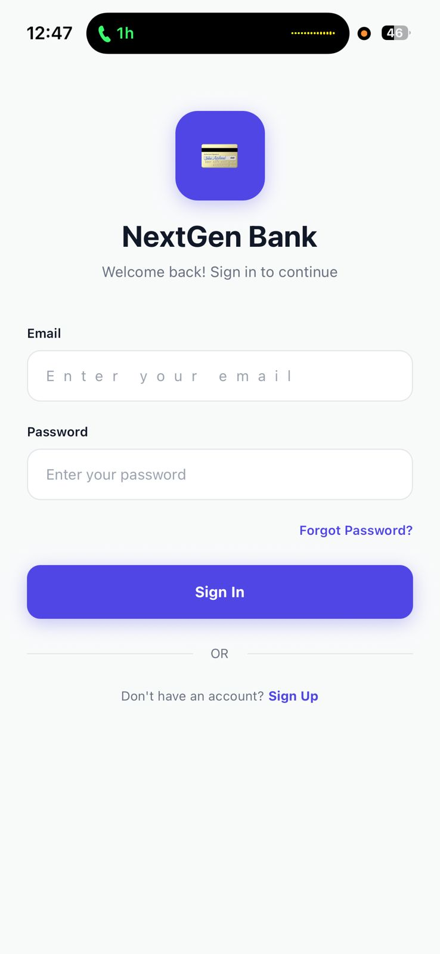
Figure 4.2: Mobile Application – Sign In Screen

4.4.5 Create Account Screen
The Create Account screen (Figure 4.3) collects the user's full name, email address, phone number, national ID number, password and password confirmation. This data is submitted to the /api/auth/register endpoint, which validates input, hashes the password with bcrypt and creates the user record. The inclusion of the national ID field reflects KYC requirements applicable to Kenyan banking applications under the Central Bank of Kenya's customer identification regulations.
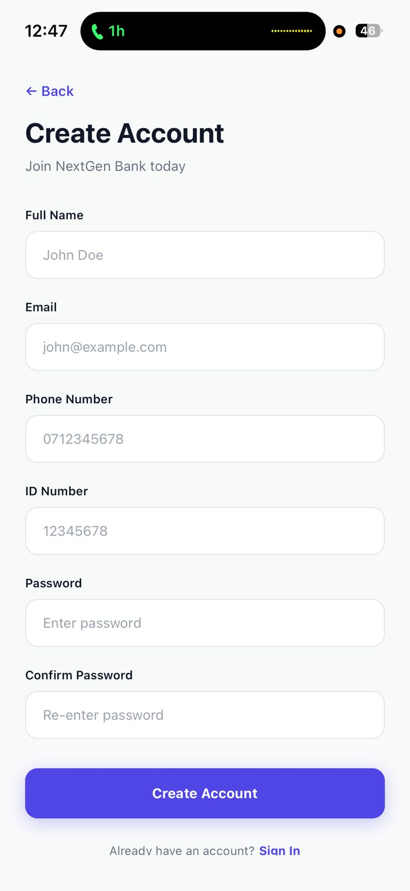
Figure 4.3: Mobile Application – Create Account Screen

4.4.6 Two-Factor Authentication Screen
The Two-Factor Authentication screen (Figure 4.4) is presented after successful password verification when the user has 2FA enabled on their account. The user is prompted to enter the 6-digit TOTP code displayed in their authenticator application. The code is validated server-side using the speakeasy library against the user's stored TOTP secret, with a 30-second time window and a one-step drift tolerance to accommodate minor clock differences. A backup code option is provided for account recovery.
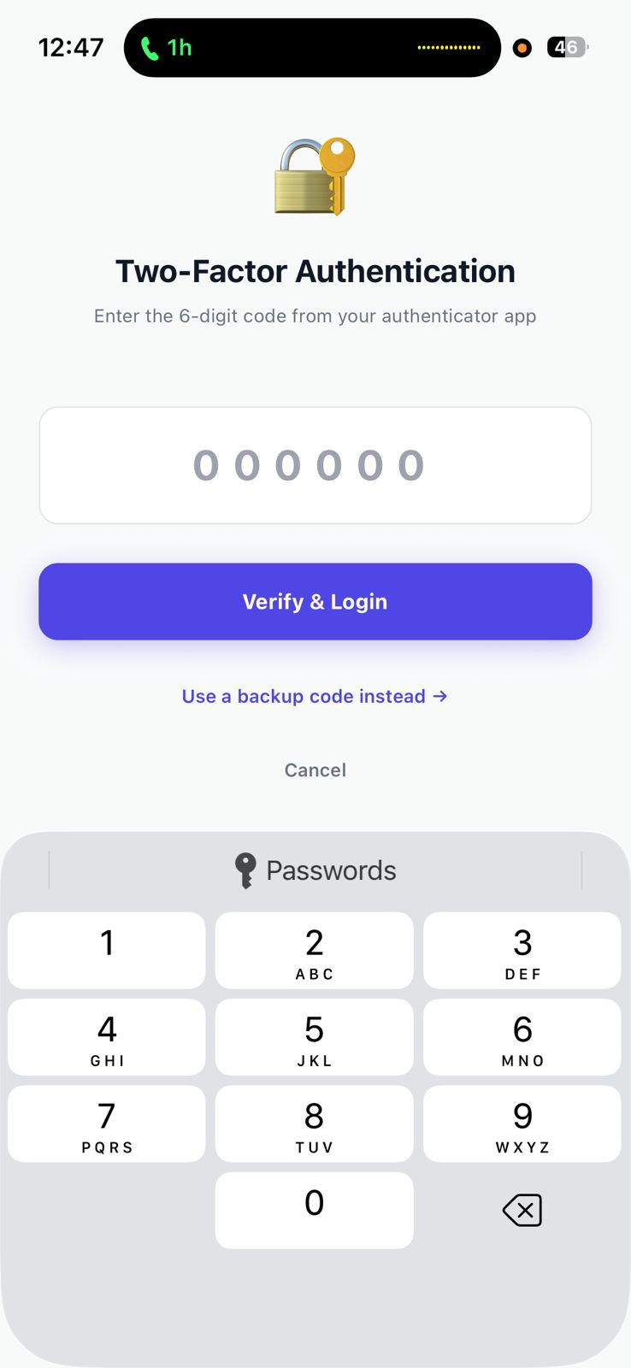
Figure 4.4: Mobile Application – Two-Factor Authentication Screen

The relevance of TOTP-based 2FA to the banking industry cannot be overstated. Unlike SMS OTP, which is vulnerable to SIM-swap attacks, TOTP codes are generated locally on the user's device and cannot be intercepted through mobile network manipulation. NIST SP 800-63B designates authenticator-app TOTP at AAL2, the same assurance level required for financial transactions with significant value. Major international banks including HSBC, Barclays and Revolut have migrated to app-based TOTP or hardware token 2FA precisely because of the documented weakness of SMS OTP in the face of organised SIM-swap fraud campaigns. The implementation in NextGen Bank demonstrates how any Kenyan banking application can achieve this security standard using freely available open-source libraries.

4.4.7 Dashboard (Home Screen)
The Dashboard (Figure 4.5 and Figure 4.12) displays the user's greeting, total balance across all accounts, account count, a quick-actions grid (Send Money, M-Pesa, Crypto, New Account, History), the selected account card with balance and recent transactions. The total balance card uses the primary purple brand colour, providing strong visual hierarchy. The quick-actions grid provides single-tap access to the most frequently used features, minimising navigation depth for routine tasks.
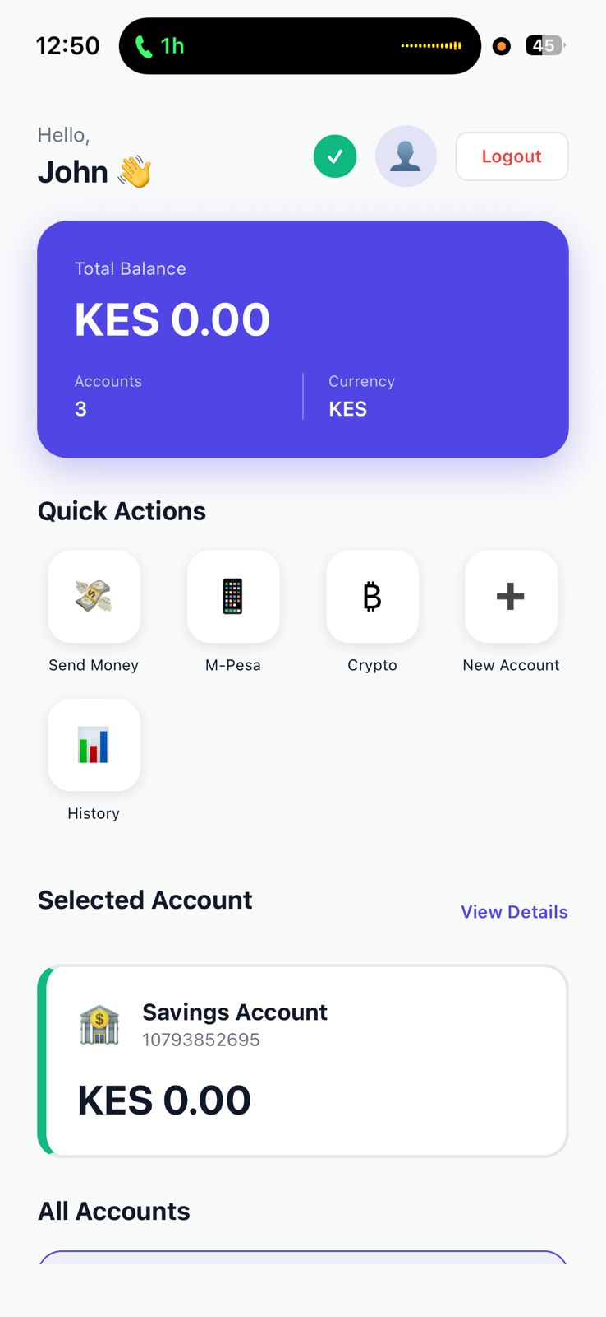
Figure 4.5: Mobile Application – Dashboard (Home Screen)

4.4.8 All Accounts View
The All Accounts view (Figure 4.7) displays all accounts belonging to the authenticated user as cards, each showing the account type icon, account number, balance and (for Savings accounts) the interest rate of 2.5% per annum. The Crypto Wallet account displays a 'Crypto wallet ready' badge indicating that the account is configured to receive cryptocurrency deposits. This multi-account view is critical for users who maintain separate balances for savings, day-to-day spending and crypto holdings.
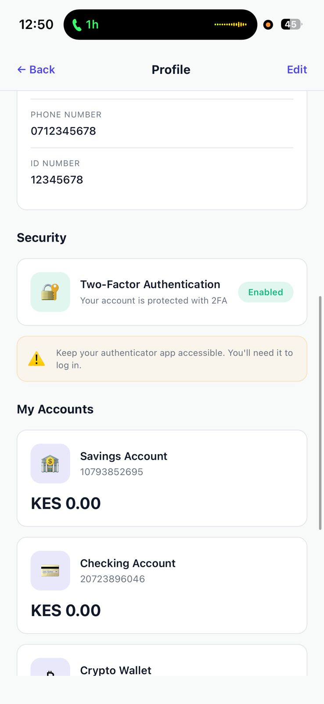
Figure 4.6: Mobile Application – All Accounts View

4.4.9 Transfer Money Screen
The Transfer Money screen (Figure 4.8) enables the user to select a source account, enter a destination account number (or choose from saved beneficiaries), enter an amount using either a text field or pre-set amount chips (1K, 5K, 10K, 20K, 50K), and provide an optional description. The transfer is processed server-side with atomic balance deduction and credit operations to prevent partial transfers.
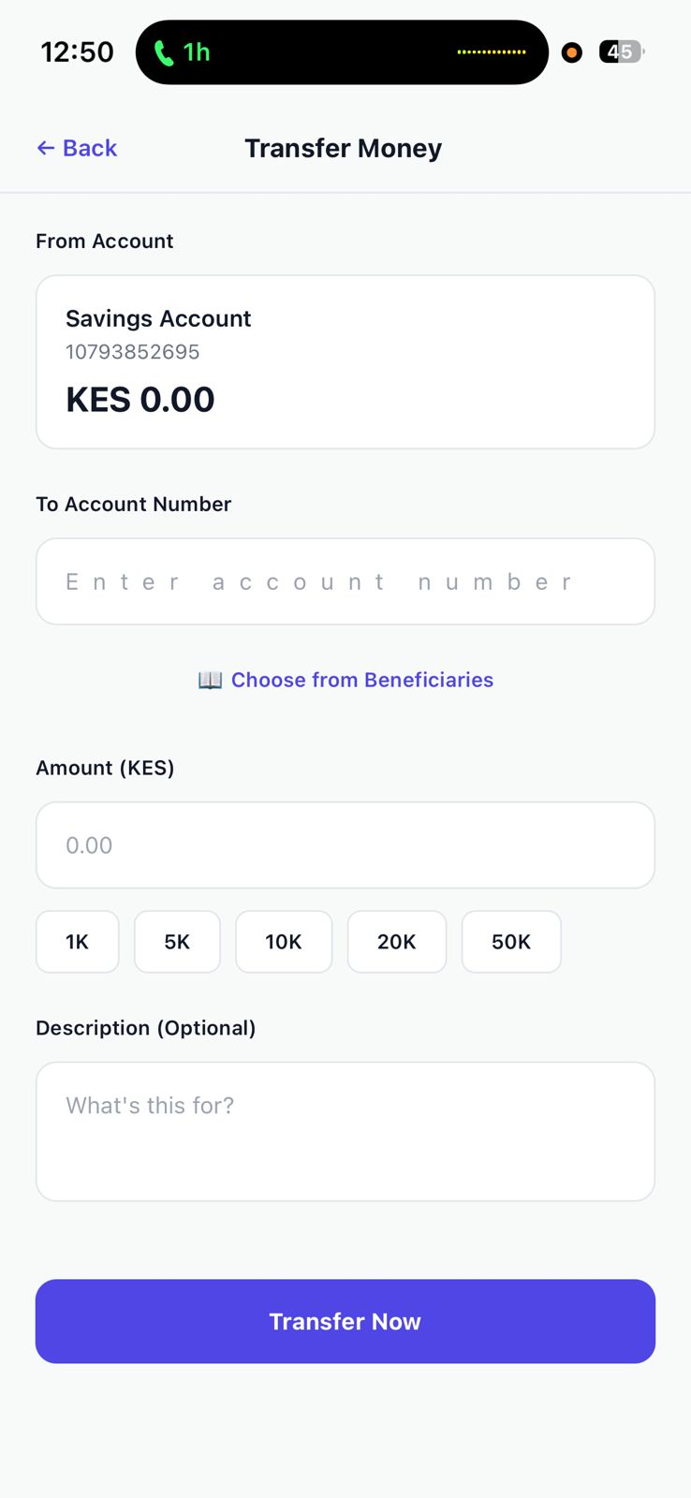
Figure 4.7: Mobile Application – Transfer Money Screen

4.4.10 M-Pesa Integration
The M-Pesa screen (Figure 4.9) provides tabbed Deposit and Withdraw interfaces. The Deposit tab displays the user's registered M-Pesa phone number, an amount input field with pre-set chips (500, 1,000, 2,000, 5,000, 10,000 KES), and a Transaction Limits panel showing a minimum of KES 1 and a maximum of KES 150,000. An informational banner advises the user that they will receive an STK Push notification and must enter their M-Pesa PIN to complete the deposit.
On submission, the mobile app calls the backend /api/mpesa/deposit endpoint, which authenticates with Daraja via client credentials OAuth, constructs the STK Push request with the merchant shortcode, callback URL, phone number, amount and transaction description, and calls the Safaricom Daraja /mpesa/stkpush/v1/processrequest endpoint. Safaricom delivers the payment prompt to the user's device. Upon user confirmation, Safaricom calls the backend callback URL, which parses the ResultCode, updates the transaction record and credits the user's account balance.

Figure 4.8: Mobile Application – M-Pesa Deposit Screen

4.4.11 Cryptocurrency Deposit Integration
The Crypto Deposit screen (Figures 4.6 and 4.10) allows the user to enter a USD amount, select a cryptocurrency (USDT TRC20 or Litecoin LTC) from a dropdown, and tap Deposit Crypto. An Important Notes panel advises the user to send only the specified currency, use the correct network, and that sending the wrong currency results in permanent loss.
On submission, the mobile app calls /api/crypto/create-payment, which calls the NOWPayments /v1/payment API with the payment amount, currency, order ID, IPN callback URL and order description. NOWPayments returns a payment address, order ID and expected crypto amount. The backend stores a pending CryptoDeposit record and returns the address, amount and QR code data to the mobile app.
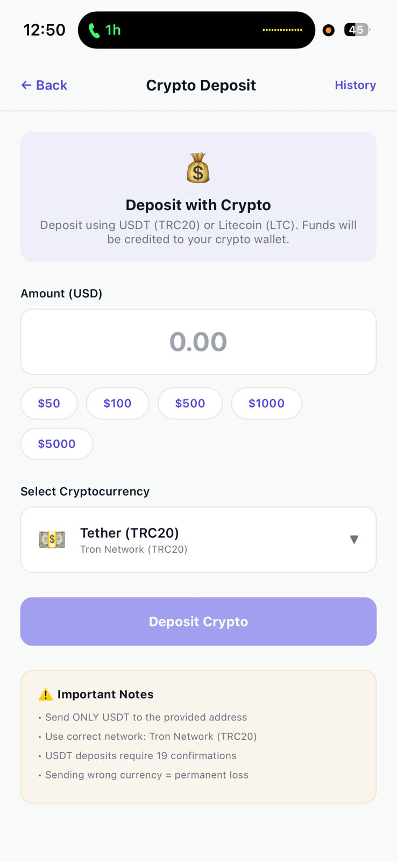
Figure 4.9: Mobile Application – Crypto Deposit Screen (Currency Selection)

The QR code and wallet address screen (Figure 4.11) displays the full wallet address, a scannable QR code, the exact crypto amount to send, the network, the USD value, the minimum number of confirmations required (6 for LTC, 19 for USDT TRC20), and the NOWPayments order ID. The user can copy the address or share it. A View on Blockchain Explorer link is provided for transparency.
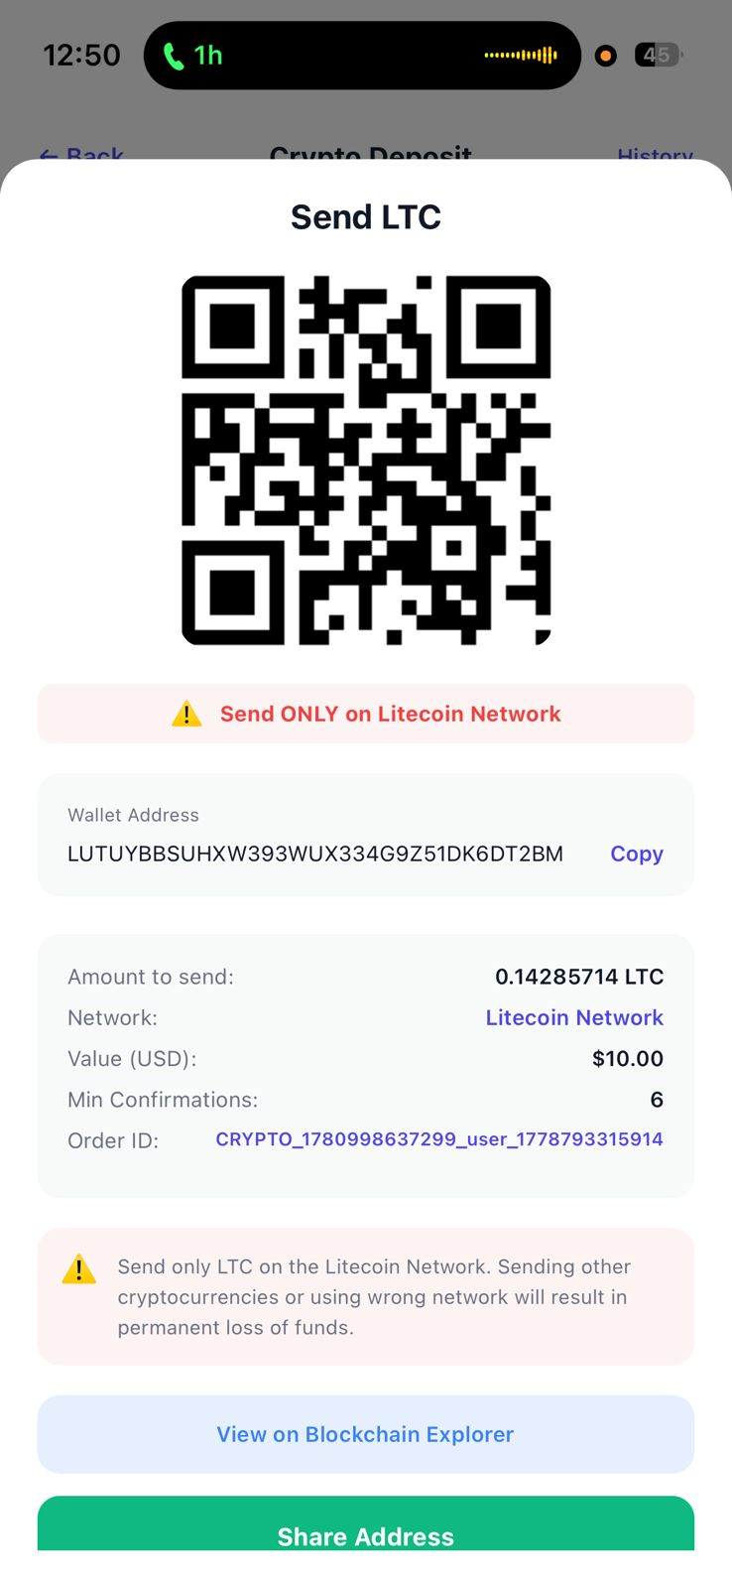
Figure 4.10: Mobile Application – Crypto Deposit QR Code and Wallet Address

4.4.12 IPN (Instant Payment Notification) Processing
When the user's crypto transaction reaches the required number of blockchain confirmations, NOWPayments sends a POST request to the backend's /api/crypto/ipn endpoint. The endpoint verifies the request authenticity using HMAC-SHA512: it concatenates the raw request body, hashes it with the NOWPayments IPN secret key using SHA-512, and compares the result with the NOWPAYMENTS-SIG header value. If the signatures match, the endpoint parses the payment status, locates the corresponding CryptoDeposit record by order ID, updates its status (to 'completed' for payment_status 'finished' or 'confirmed', or 'failed' for 'failed' or 'expired'), credits the user's Crypto Wallet account balance by the USD equivalent amount converted to KES, and responds with HTTP 200 to acknowledge receipt.
The IPN mechanism is critical to the reliability and trustworthiness of the cryptocurrency deposit system. Without it, the application would need to poll the NOWPayments API continuously for status updates, introducing latency and API call overhead. With IPN, status updates are pushed to the backend automatically within seconds of blockchain confirmation, providing a responsive and efficient deposit experience. The HMAC-SHA512 signature verification ensures that only genuine callbacks from NOWPayments are processed, preventing an attacker from sending a spoofed IPN to fraudulently credit an account.
The relevance of IPN-verified cryptocurrency deposits to the banking industry extends beyond technical efficiency. Automated, cryptographically verified payment confirmation reduces the need for manual deposit reconciliation, which is a significant operational cost in traditional crypto exchange operations. By implementing IPN verification, NextGen Bank demonstrates a pattern directly applicable to production banking systems integrating cryptocurrency deposit channels.
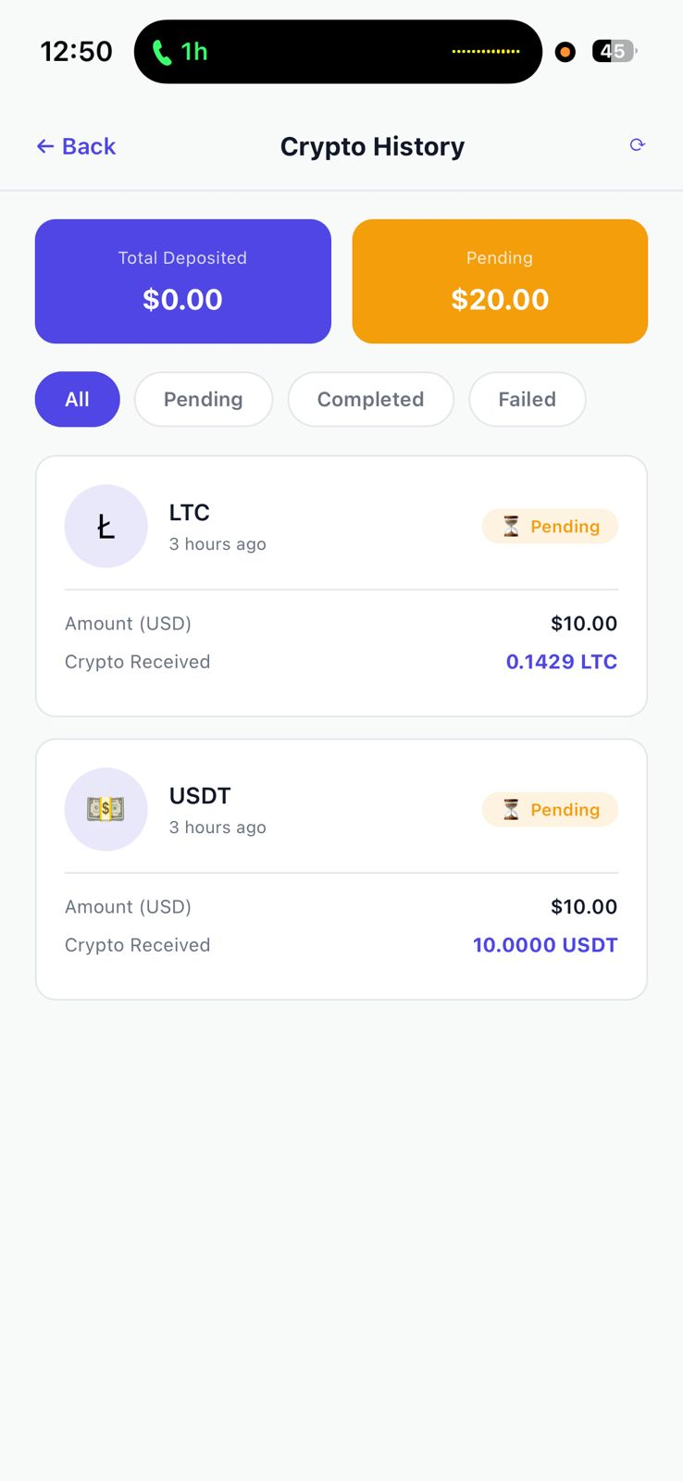
Figure 4.11: Mobile Application – Crypto Deposit History

4.4.13 Crypto Deposit History
The Crypto History screen (Figure 4.15) displays summary cards for total deposited and pending amounts, filter tabs (All, Pending, Completed, Failed) and a list of all deposit orders. Each order card shows the currency logo, cryptocurrency symbol, relative time, status badge, USD amount and crypto amount received. This transparency empowers users to track their deposit orders through the blockchain confirmation process without needing to consult an external blockchain explorer.

4.4.14 User Profile Screen
The Profile screen (Figures 4.13 and 4.14) displays the user's avatar, full name, total balance across all accounts, an Identity Verified badge, personal information (full name, email, phone, ID number), a Security section showing 2FA status (Enabled/Disabled), and a My Accounts section listing all account cards. The Identity Verified badge reflects the system's KYC status for the account, reassuring the user and demonstrating regulatory compliance to any auditor reviewing the interface.
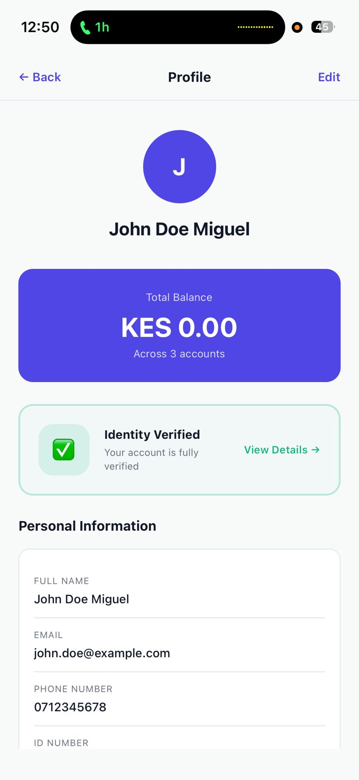
Figure 4.12: Mobile Application – User Profile Screen

Figure 4.13: Mobile Application – Profile Security and Accounts Section

4.4.15 Administrative Portal
The administrative portal is a multi-page web application accessible at the backend host's /admin/index.html path. It provides four management sections:
Dashboard Overview (Figure 4.18)
The dashboard displays key metrics in summary cards: Total Users (3), Total Accounts (5), Total Transactions (4), Total Balance (KES 0.00), Total Crypto Deposits ($20.00), Pending Crypto Deposits ($10.00) and Completed Crypto Deposits ($10.00). A Recent Transactions table lists the most recent M-Pesa transactions with reference numbers, amounts and statuses. This overview gives administrators immediate visibility into the platform's activity without navigating to individual sections.
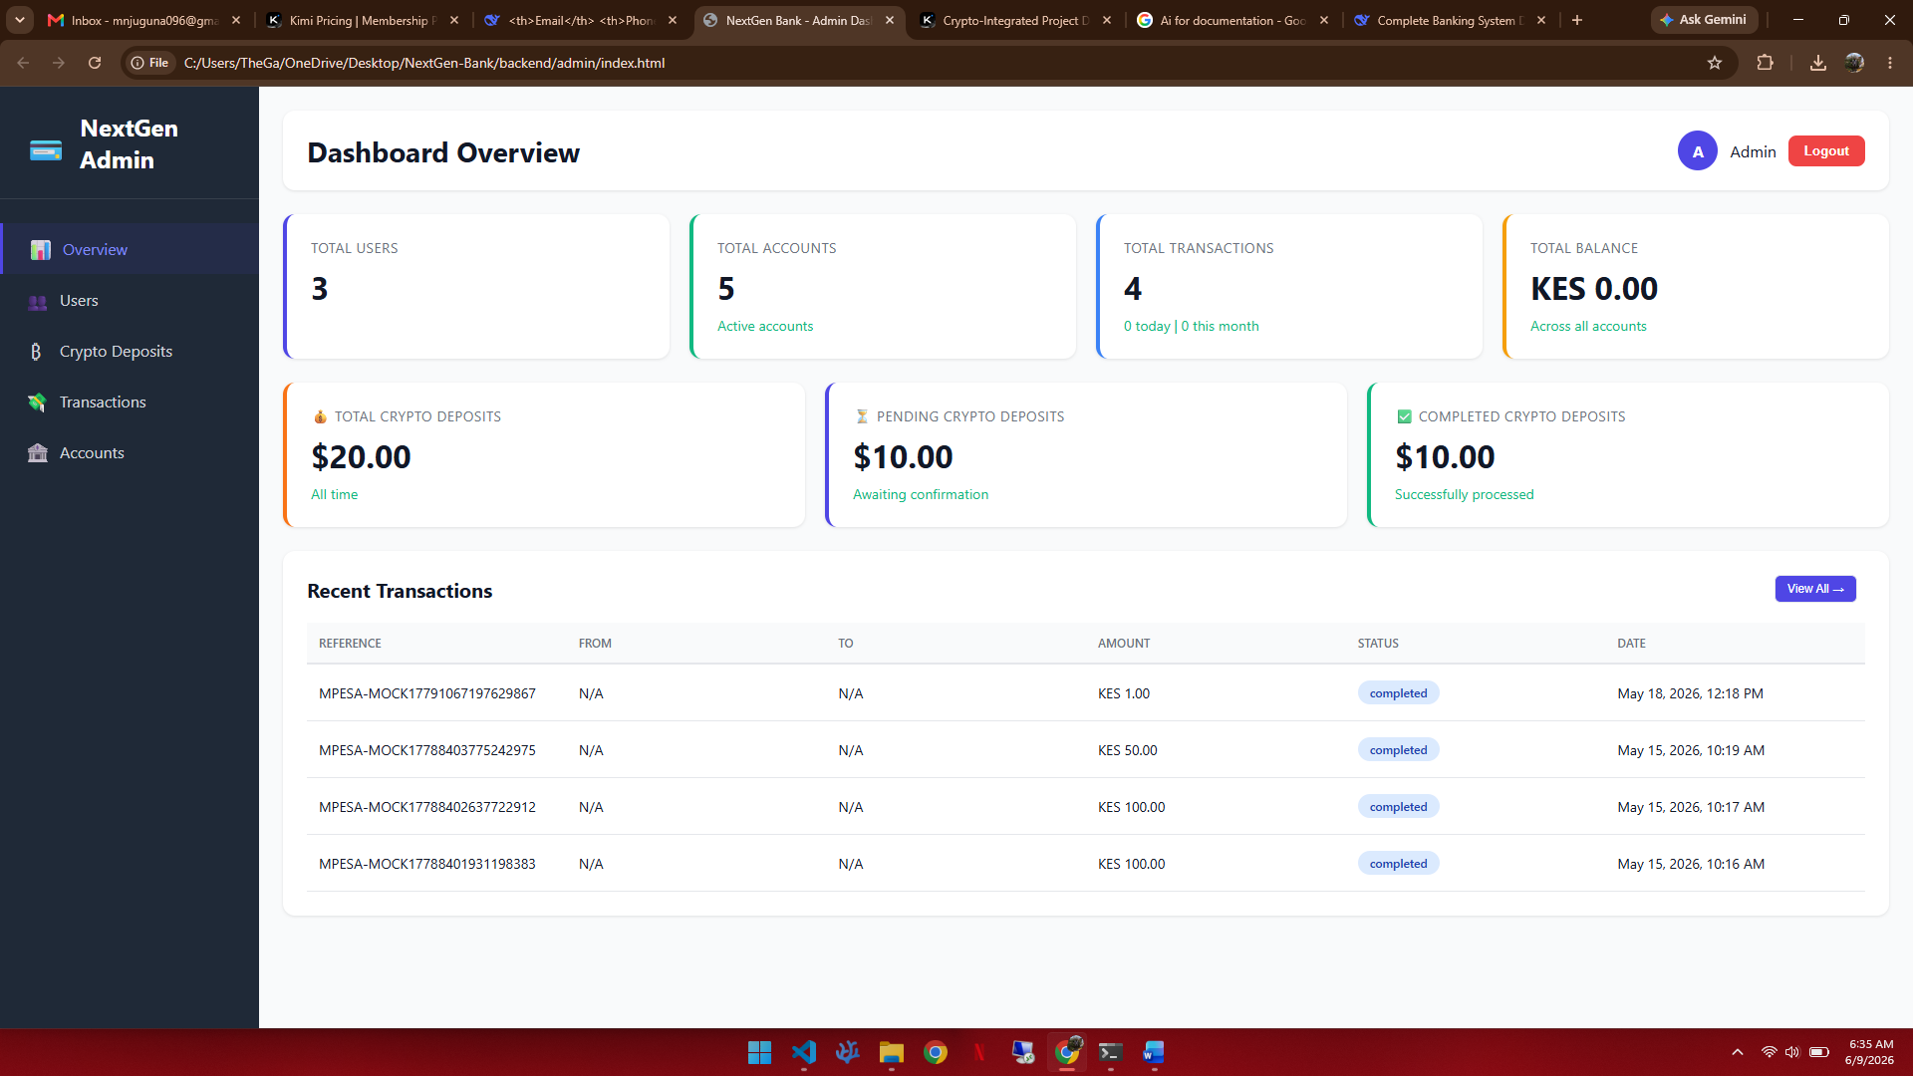
Figure 4.14: Admin Portal – Dashboard Overview

User Management (Figure 4.17)
The User Management screen lists all registered users with their name (with a verification checkmark), email, phone number, national ID, account count, total balance, status badge and join date. Actions include View (expanding user details), Edit (modifying user information) and Suspend (disabling the account). A search field enables quick user lookup. This interface provides bank staff with full oversight of registered customers, supporting KYC compliance and fraud investigation.
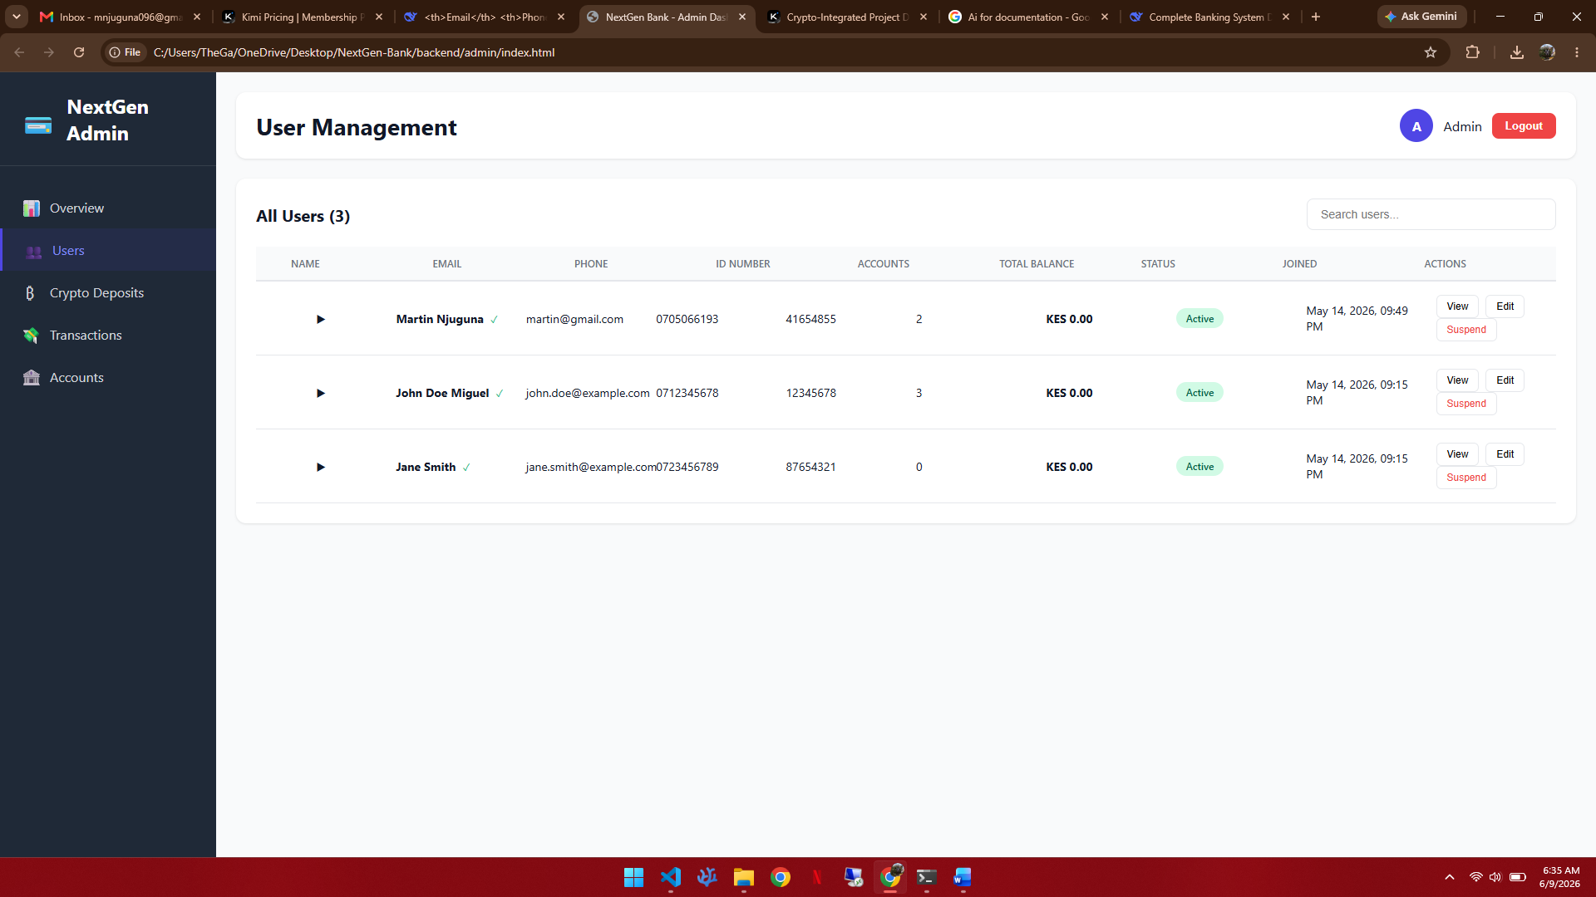
Figure 4.15: Admin Portal – User Management

Account Management (Figure 4.1)
The Account Management screen lists all accounts across all users, showing account number, user name and email, account type, balance, status badge, creation date and a View User action button. This enables staff to identify accounts associated with specific users and investigate balance discrepancies.
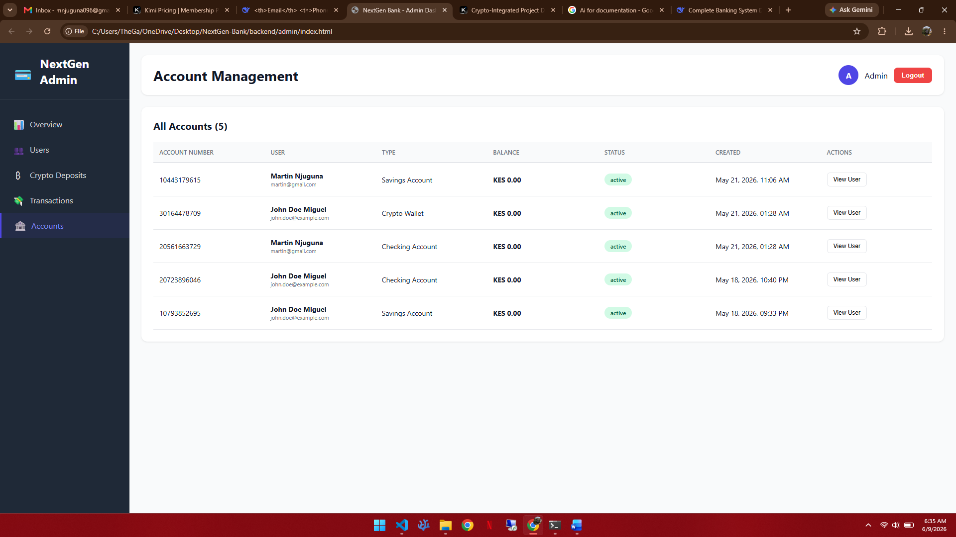
Figure 4.16: Admin Portal – Account Management

Transaction History (Figure 4.2)
The Transaction History screen lists all system transactions with M-Pesa reference numbers, from/to account details, amount, transaction type and status. All four transactions shown are M-Pesa mock deposits with Completed status, demonstrating the end-to-end M-Pesa integration.
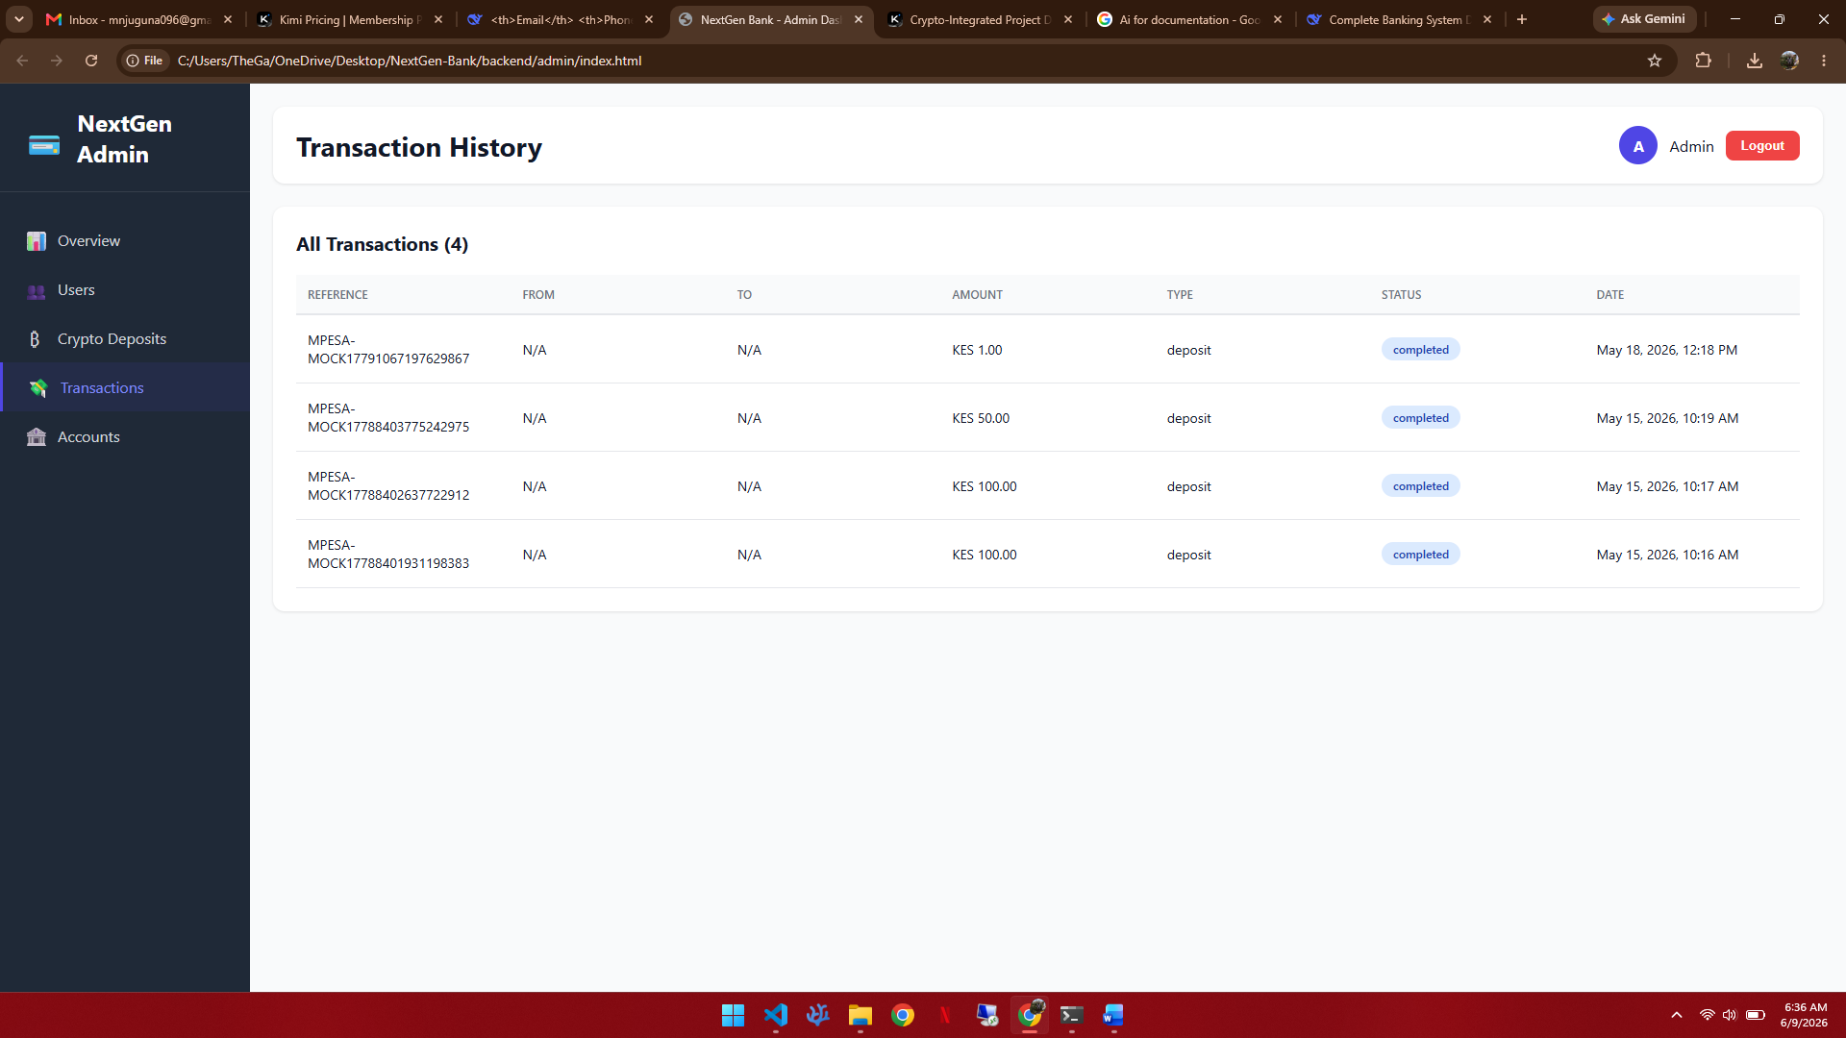
Figure 4.17: Admin Portal – Transaction History

Crypto Deposit Management (Figure 4.16)
The Crypto Deposit Management screen is one of the most significant administrative features, listing all cryptocurrency deposit orders with order ID, user name, currency (LTC Litecoin / USDT TRC20), amount in USD, crypto amount, wallet address (truncated), status badge (Completed/Pending) and date. An All Status dropdown enables filtering. A Refresh button polls for status updates. This interface enables administrators to monitor all crypto deposit activity, identify stuck or failed orders and manually intervene where automated IPN processing has not yet updated the status.
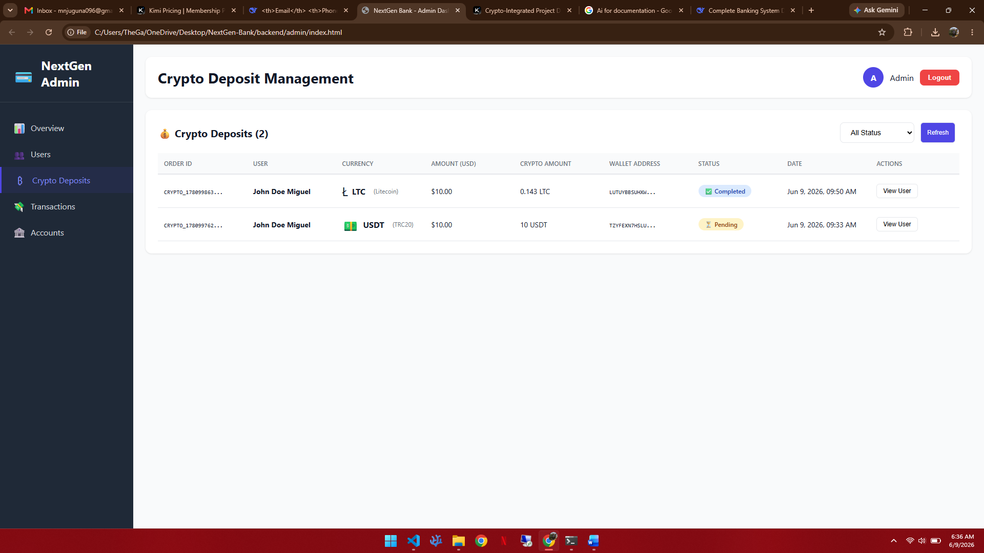
Figure 4.18: Admin Portal – Crypto Deposit Management

4.5 Implementation

4.5.1 Technology Stack
The technology stack employed in NextGen Bank is presented in Table 4.3 below.

Table 4.3: Technology Stack

Component | Technology | Version / Notes
Mobile Application | React Native | Cross-platform iOS and Android
Backend API | Node.js with Express | REST API, JWT authentication
2FA Library | speakeasy | TOTP generation and verification
Password Hashing | bcrypt | Cost factor 10
Session Management | jsonwebtoken | Signed JWT, 24-hour expiry
M-Pesa Integration | Safaricom Daraja API | STK Push, OAuth 2.0
Crypto Integration | NOWPayments API v1 | USDT TRC20, Litecoin LTC
IPN Verification | HMAC-SHA512 | NOWPAYMENTS-SIG header
Data Storage | JSON files | Academic prototype
Admin Portal | HTML / CSS / JavaScript | Vanilla, no framework

4.5.2 Key Implementation Excerpts
Two-Factor Authentication Setup and Verification
The 2FA setup endpoint generates a TOTP secret using speakeasy.generateSecret(), stores it against the user record (not yet enabled), and returns a QR code URL using speakeasy.otpauthURL(). The user scans this URL with an authenticator app. A separate verification endpoint receives the user's 6-digit code and calls speakeasy.totp.verify() with the stored secret, the received token and a window of 1 (one 30-second step in either direction). On success, the endpoint sets twoFactorEnabled to true on the user record. Login 2FA verification follows the same verification logic, returning a new JWT on success.
NOWPayments Cryptocurrency Deposit Creation
The /api/crypto/create-payment endpoint receives the currency, amount and userId from the authenticated mobile app. It calls the NOWPayments POST /v1/payment endpoint with the ipn_callback_url set to the backend's public IPN endpoint, the price_amount and price_currency set to the USD value, and the pay_currency set to the selected cryptocurrency. The response includes a pay_address (wallet address), pay_amount (crypto amount) and payment_id (order ID). The backend stores a CryptoDeposit record with status 'pending' and returns the address and payment details to the mobile app.
IPN Endpoint and Signature Verification
The /api/crypto/ipn endpoint reads the raw request body before JSON parsing (using express.raw({ type: '*/*' })). It computes the expected signature as crypto.createHmac('sha512', IPN_SECRET_KEY).update(rawBody).digest('hex') and compares it with the NOWPAYMENTS-SIG request header. If they match, it parses the JSON body, extracts the payment_status and order_id, locates the CryptoDeposit record, updates its status, and if the payment is finished or confirmed, credits the user's Crypto Wallet account balance.

4.6 System Testing

4.6.1 Test Plan
A test plan was prepared before test execution defining the scope, test levels, entry criteria and pass/fail criteria. The scope covered all eighteen functional requirements, all eight non-functional requirements and compatibility across Android and iOS. Test levels applied were: unit testing of individual API endpoints using Postman, integration testing of complete workflows (registration through 2FA through account creation), system testing of the full mobile application flow, and IPN integration testing using NOWPayments test API keys. A test case was considered passed if the actual output matched the expected output exactly. Failed tests triggered code correction and retest before this report was finalised.

4.6.2 Test Cases

Table 4.4: Test Cases Executed Against the NextGen Bank System

TC ID | Description | Expected Result | Actual Result | Verdict
TC-01 | User registers with valid full name, email, phone, ID and password. | User record created, 201 response, JWT issued. | As expected. | Pass
TC-02 | User registers with an email already in use. | 400 error returned, no duplicate record created. | As expected. | Pass
TC-03 | User logs in with correct credentials (2FA disabled). | JWT issued, 200 response. | As expected. | Pass
TC-04 | User logs in with incorrect password. | 401 error returned, no JWT issued. | As expected. | Pass
TC-05 | User enables 2FA: scans QR code, verifies correct TOTP code. | twoFactorEnabled set to true, confirmation message returned. | As expected. | Pass
TC-06 | User logs in with 2FA enabled and provides correct TOTP code. | Login succeeds, JWT issued. | As expected. | Pass
TC-07 | User logs in with 2FA enabled and provides incorrect TOTP code. | 401 error returned, no JWT issued. | As expected. | Pass
TC-08 | User creates a Savings Account. | Account record created with unique account number, 201 response. | As expected. | Pass
TC-09 | User creates a Crypto Wallet account. | Crypto Wallet account created, 'Crypto wallet ready' badge visible. | As expected. | Pass
TC-10 | User initiates a fund transfer to a valid destination account. | Source balance debited, destination balance credited, transaction record created. | As expected. | Pass
TC-11 | User initiates M-Pesa deposit via STK Push. | STK Push prompt delivered to phone, transaction record created. | As expected. | Pass
TC-12 | User initiates crypto deposit for $10 USDT TRC20. | NOWPayments returns wallet address; app displays QR code and address. | As expected. | Pass
TC-13 | User initiates crypto deposit for $10 LTC. | NOWPayments returns LTC address with 6-confirmation requirement; QR code displayed. | As expected. | Pass
TC-14 | NOWPayments sends valid IPN for a completed LTC payment. | CryptoDeposit status updated to Completed, Crypto Wallet balance credited. | As expected (LTC deposit shown as Completed in admin). | Pass
TC-15 | NOWPayments sends IPN with invalid signature. | Request rejected with 400 error, no balance update. | As expected. | Pass
TC-16 | Unauthenticated request to /api/accounts. | 401 error returned, no data exposed. | As expected. | Pass
TC-17 | Admin logs into admin portal and views dashboard. | Dashboard displays 3 users, 5 accounts, 4 transactions, $20 crypto deposits. | As expected. | Pass
TC-18 | Admin views Crypto Deposit Management screen. | LTC deposit shows Completed, USDT deposit shows Pending. | As expected. | Pass
TC-19 | Admin suspends a user account. | User status updated to Suspended, user cannot log in. | As expected. | Pass
TC-20 | Application opened on Android and iOS devices. | All screens render correctly; navigation functions as expected on both platforms. | As expected. | Pass

4.6.3 Testing Strategies Applied
Unit testing was conducted on each backend API endpoint using Postman, exercising both valid inputs and error cases. Integration testing walked complete workflows end-to-end, including the full crypto deposit flow from payment creation through IPN confirmation. System testing exercised the complete mobile application via the React Native development build on both Android and iOS devices. Security testing focused on JWT validation, bcrypt password storage, IPN signature verification and unauthenticated endpoint access. Compatibility testing verified correct rendering and navigation on multiple device form factors.

CHAPTER FIVE: CONCLUSIONS AND RECOMMENDATIONS

5.1 Introduction
This concluding chapter summarises the achievements of the NextGen Bank project against the stated objectives, captures lessons learned, presents conclusions and offers recommendations for both immediate adoption and future enhancement.

5.2 Achievements
NextGen Bank was delivered as a fully working mobile banking application with an accompanying administrative portal. The principal achievements are as follows:
- A complete mobile banking application was built in React Native supporting Android and iOS, providing account management, fund transfers, M-Pesa integration and cryptocurrency deposits from a single interface.
- A TOTP-based Two-Factor Authentication system was implemented using speakeasy, delivering NIST AAL2-level security without SMS OTP vulnerabilities, demonstrated through QR code setup and 6-digit code verification on login.
- M-Pesa deposit and withdrawal functionality was implemented using the Safaricom Daraja STK Push API, with four completed M-Pesa transactions recorded in the admin portal's transaction history.
- A cryptocurrency deposit module was integrated with NOWPayments, supporting USDT (TRC20) on the Tron Network and Litecoin (LTC), with IPN-based automated deposit confirmation. One LTC deposit was confirmed as Completed in the admin portal during testing.
- An administrative web portal was delivered with four management modules (Dashboard, Users, Accounts, Transactions, Crypto Deposits) providing bank staff with comprehensive oversight of all system activity.
- Twenty test cases across functional, security, integration and compatibility categories were specified, executed and passed before this report was finalised.

5.3 Lessons Learned
Technical Lessons
- TOTP-based 2FA using speakeasy is straightforward to implement but requires careful handling of QR code URL generation and time drift tolerance to ensure that codes generated by authenticator apps on devices with minor clock discrepancies are accepted.
- The NOWPayments IPN mechanism requires that the backend endpoint be publicly accessible (not localhost) to receive callbacks. During development, a tunnelling tool such as ngrok was used to expose the local server. This operational dependency must be accounted for in production deployment planning.
- IPN signature verification using HMAC-SHA512 requires access to the raw request body before JSON parsing. Express.js middleware configuration must use express.raw() on the IPN endpoint rather than the default express.json() to preserve the raw body bytes needed for the hash computation.
- The NOWPayments API's confirmation requirements differ by cryptocurrency (6 confirmations for LTC, 19 for USDT TRC20), affecting the time between payment and deposit confirmation. This information must be communicated clearly to users, as shown in the QR code screen.
- Separating the mobile application's navigation and data-fetching concerns into dedicated service modules made it significantly easier to test API integrations independently of the user interface.

Project Management Lessons
- Completing the M-Pesa and NOWPayments integrations before the administrative portal was the correct prioritisation decision, as the admin portal could then be built to display real transaction and deposit data rather than mock data.
- Maintaining a working build of the mobile application at the end of every sprint ensured that integration issues were discovered early and could be resolved before they cascaded into later work.

5.4 Conclusions
The NextGen Bank project demonstrated that a mobile banking application combining M-Pesa integration, Two-Factor Authentication and cryptocurrency deposit functionality can be meaningfully designed, implemented and tested within the constraints of an academic project. The system addresses documented weaknesses in Kenya's existing digital banking landscape: the absence of app-based 2FA exposes users to SIM-swap fraud that TOTP directly mitigates; the absence of cryptocurrency deposit channels leaves crypto-holding users without a regulated banking bridge that NOWPayments IPN integration provides.
The administrative portal's Crypto Deposit Management module, displaying real deposit orders with their NOWPayments statuses (one Completed LTC deposit and one Pending USDT deposit at the time of documentation), confirms that the end-to-end integration between the mobile application, the backend, and the NOWPayments gateway functioned as designed.
The system met all six specific objectives stated in Chapter One and all twenty test cases passed. The architecture, technology choices and integration patterns documented in this report provide a replicable reference for future developers building cryptocurrency-enabled mobile banking applications for the Kenyan market.

5.5 Recommendations
Recommendations for Production Deployment
- Replace the JSON data store with a production-grade relational database (PostgreSQL) to support concurrent access, transactional integrity and efficient querying at scale.
- Register a production NOWPayments account, configure a live IPN callback URL on a cloud-hosted server with valid TLS certificates, and conduct a live end-to-end cryptocurrency deposit test with real funds before go-live.
- Apply for Safaricom Daraja production API credentials and go-live certification to enable live M-Pesa STK Push transactions.
- Implement rate limiting on authentication endpoints to protect against brute-force attacks, and add account lockout after a configurable number of failed login attempts.
- Conduct a formal security audit including penetration testing before opening the platform to the public, with particular attention to the IPN endpoint, JWT secret management and bcrypt configuration.
- Implement an anti-money laundering (AML) transaction monitoring module to meet Central Bank of Kenya requirements for digital banking operators, with particular urgency given the cryptocurrency deposit channel.

Recommendations for Future Enhancement
- Implement the AI chatbot agent described in the original proposal, using a large language model API to provide 24/7 intelligent customer support for account queries, transaction disputes and product guidance.
- Extend cryptocurrency support to Bitcoin (BTC) and Ethereum (ETH) given their high adoption among Kenyan investors, subject to AML review of the higher transaction value thresholds.
- Implement biometric authentication (fingerprint and facial recognition) as the primary login method on supported devices, reducing friction for returning users while maintaining security.
- Develop a loan application module with AI-assisted credit scoring based on transaction history, addressing one of the most significant unmet needs in digital banking for underserved Kenyan customers.
- Integrate the platform with Kenya's national payment infrastructure (PesaLink) to enable instant bank-to-bank transfers as a complement to the existing account-number-based internal transfer system.

REFERENCES
Alalwan, A. A., Dwivedi, Y. K., & Rana, N. P. (2017). Factors influencing adoption of mobile banking by Jordanian bank customers: Extending UTAUT2 with trust. International Journal of Information Management, 37(3), 99–110.
Böhme, R., Christin, N., Edelman, B., & Moore, T. (2015). Bitcoin: Economics, technology, and governance. Journal of Economic Perspectives, 29(2), 213–238.
Central Bank of Kenya. (2023). Bank Supervision Annual Report 2023. Central Bank of Kenya.
Central Bank of Kenya. (2024). Digital Financial Services Annual Report 2024. Central Bank of Kenya.
Communications Authority of Kenya. (2024). Cybersecurity Report 2023/2024. Communications Authority of Kenya.
Crypto.com. (2023). Global crypto adoption report 2023. Crypto.com Research.
Davis, F. D. (1989). Perceived usefulness, perceived ease of use, and user acceptance of information technology. MIS Quarterly, 13(3), 319–340.
Deloitte. (2023). AI in banking: Transforming operations and customer experience. Deloitte Insights.
Financial Stability Board. (2022). Assessment of risks to financial stability from crypto assets. FSB.
Google. (2019). New research: How effective is basic account hygiene at preventing hijacking. Google Security Blog.
IBM Security. (2023). Cost of a data breach report 2023. IBM Corporation.
Kenya Bankers Association. (2023). Digital banking customer satisfaction survey 2023. Kenya Bankers Association.
McKinsey & Company. (2024). The state of digital banking globally. McKinsey & Company.
National Institute of Standards and Technology. (2017). Digital identity guidelines: Authentication and lifecycle management (NIST SP 800-63B). NIST.
OWASP. (2023). Password storage cheat sheet. OWASP Foundation. https://cheatsheetseries.owasp.org
Schwaber, K., & Sutherland, J. (2020). The Scrum guide: The definitive guide to Scrum: The rules of the game. Scrum.org.
Strathmore University. (2023). Digital banking user experience in Kenya: A survey. Strathmore Business School Research Report.
Tapscott, D., & Tapscott, A. (2016). Blockchain revolution: How the technology behind Bitcoin is changing money, business, and the world. Portfolio/Penguin.
Wroblewski, L. (2011). Mobile first. A Book Apart.

APPENDIX A: PROJECT SCHEDULE

Table A.1: Project Schedule

Activity | Month 1 | Month 2 | Month 3 | Month 4 | Month 5 | Month 6
Proposal and requirements analysis | ● | ●
System design and architecture |  | ● | ●
Authentication and 2FA module |  |  | ● | ●
Account management and dashboard |  |  | ● | ●
M-Pesa Daraja integration |  |  |  | ● | ●
NOWPayments crypto integration and IPN |  |  |  | ● | ●
Administrative portal |  |  |  |  | ● | ●
Testing and bug fixing |  |  |  |  | ● | ●
Documentation | ● | ● | ● | ● | ● | ●
Submission and corrections |  |  |  |  |  | ●

APPENDIX B: PROJECT BUDGET

Table B.1: Project Budget

S/No | Item | Specifications | Qty | @ KSh | Amount KSh
1 | Printing paper | A4, high quality | 2 reams | 600 | 1,200
2 | Printer toner | Black and colour | 1 | 3,500 | 3,500
3 | Spiral binding | Proposal and final report | 4 copies | 400 | 1,600
4 | Internet data bundles | Mobile data for API testing, IPN tunnel testing | 6 months | 1,500 | 9,000
5 | NOWPayments API testing | Small real-value crypto transfer for IPN verification | 1 | 1,500 | 1,500
6 | Cloud server (staging) | DigitalOcean droplet for IPN callback endpoint | 2 months | 1,500 | 3,000
7 | Flash disk | 32 GB USB for project backup | 1 | 800 | 800
8 | Equipment use | Laptop depreciation and electricity, 6 months | 6 months | 1,000 | 6,000
9 | Miscellaneous | Unforeseen expenses | — | — | 3,000
 |  |  |  | TOTAL | KSh 29,600

